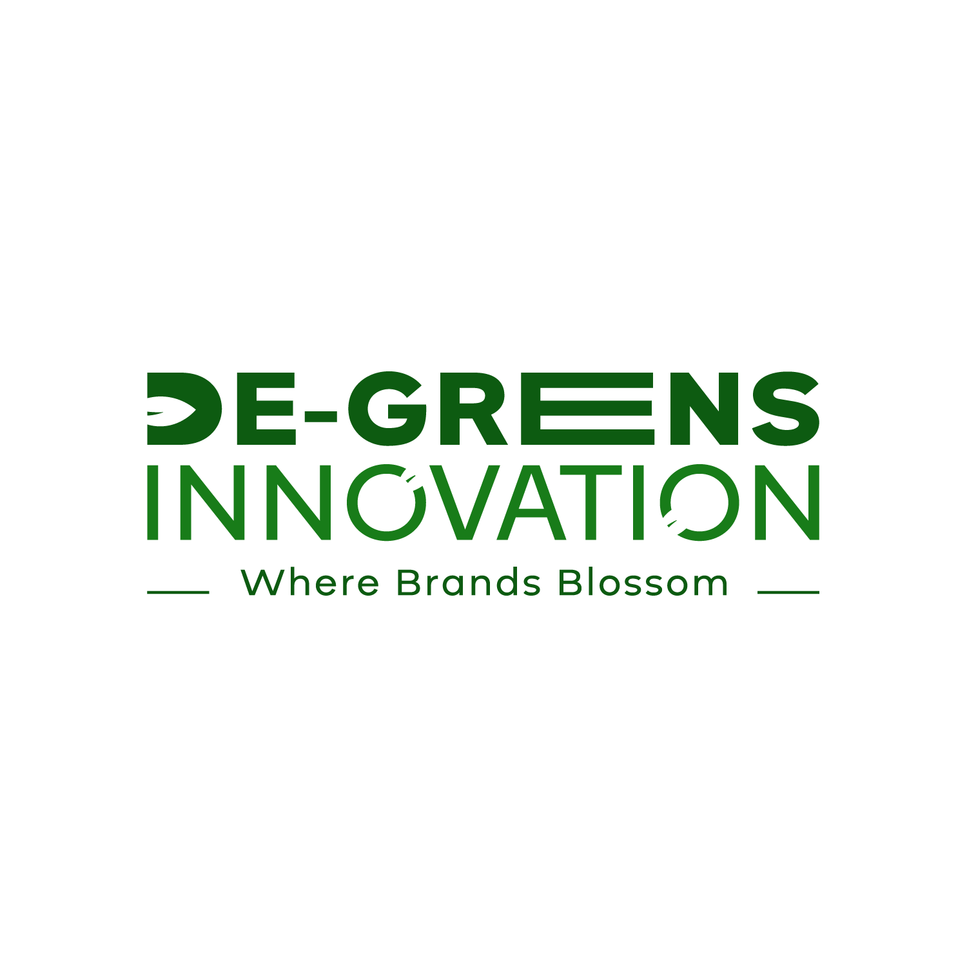

DE-GREENS INNOVATION
COMPANY PROFILE

ABOUT US
DE-GREENS INNOVATION is a leading print media and branding firm dedicated to providing top-notch printing and branding solutions to businesses and organizations. With a team of experienced professionals and state-of-the-art equipment, we deliver high-quality print and branding products that exceed our clients' expectations.
In a world where growth is paramount, our print media branding firm stands as the nurturing soil that cultivates ideas into vibrant blooms of success. Like the verdant hue of nature's renewal, we infuse every design with creativity, fostering client visions to reach full fruition. With each print, we not only spread messages, but plant seeds of possibility that blossom into thriving campaigns. Embrace the power of GREENS with us, where every impression signifies not just growth, but a flourishing tapestry of innovation and potential.

Focus Areas
- Print Media Solutions: Business cards, brochures, flyers, posters, and more.
- Branding and Identity: Logo design, corporate stationery, and brand guidelines.
- Advertising and Marketing: Print ads, promotional materials, and campaign development.

Vision Statement:
To be the leading provider of innovative solutions that empower individuals and businesses to thrive in a rapidly evolving world, by leveraging cutting-edge technology and fostering a culture of creativity, collaboration, and excellence.

Mission Statement:
We are dedicated to satisfying our customers' needs through innovative solutions, consistent quality, and transparent practices. We are committed to building long-lasting relationships, fostering growth and development, and nurturing creativity and ideation. Our focus on branding, customer satisfaction, and partnerships drives us to consistently exceed expectations and create a positive impact on the world.

Core Values:
Quality, customer satisfaction, innovation, and sustainability.

Unique Selling Proposition (USP):
Your brand, amplified: expert print media solutions that increase visibility, build connections, and drive growth.

Services:
Digital printing, offset printing, branding, advertising & packaging.
Target Audience:
Our target audience include but not limited to start-up businesses, small businesses, non-profits, schools, restaurants and cafes, retail stores, shops and markets.

Elevator Pitch:
From business cards to billboards, we help brands like yours make a lasting impression.

CONTACT US
+233 (0) 50 461 8929
degreensinnovationltd@gmail.com

